Flatirons Community Church Build Overview
Project: Wonderland Creek, Boulder
Date(s): September 20th, October 18th, November 15th and December 20th, 2014
Project Type: Construction
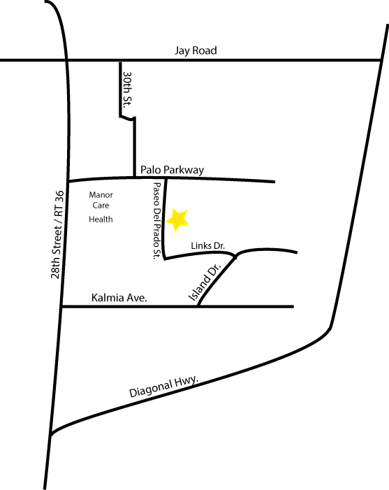
Instructions: No construction experience necessary, just a willing heart.
What you need to know and bring for your day:
• We will provide all necessary tools and training. Please bring a water bottle, closed-toed shoes, and layered clothing appropriate for both indoor and outdoor work. Coffee, water, and snacks are available at the construction site. LUNCH will be provided.
• All construction days are full days from 8:00 a.m. to 4:00 p.m. The construction site orientation and safety review occurs at 8:00 a.m. and is required for you to be able to work on the site. We cannot accept partial day volunteering.
• All volunteers must sign and submit a 2 page waiver of liability and safety form. Safety Waiver must be completed.
• All volunteers must be AT LEAST 16 years old (a parent or legal guardian must sign the waiver for volunteers 16-17). Sixteen and 17 year old volunteers must be accompanied by an adult/guardian.
• All volunteers must be on the schedule.
• We will post any weather related closures at 6:30 a.m. the day of the build on our Facebook page. (Go to www.flatironshabitat.org and click on the Facebook icon.)
We look forward to seeing you on the construction site!
Please feel free to contact us if you have any questions. Casey Payne, Director of Communications 303-447-3787 Ext. 234
The construction site is located off of Paseo del Prado St. in Boulder, 80301. Look for Habitat for Humanity banner.

