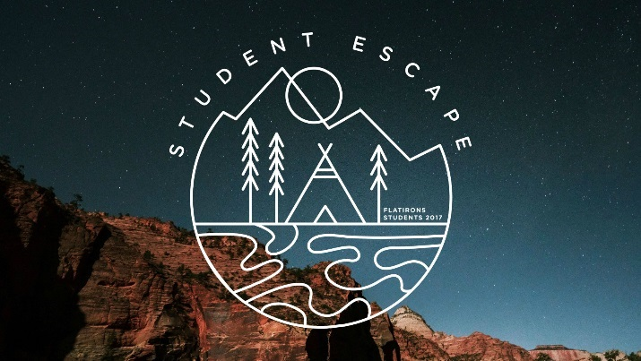
Student Escape Registration
August 1-5th | Glorieta Camp – Glorieta, NM
Full Price $425 | Cash or check | Deposit of $75 due with packet | Full amount due by August 1st
Please read and/or complete all sections of this packet.
STUDENT FULL NAME Click or tap here to enter text.
GRADE (for 2017/2018 school year): ☐ 6th ☐ 7th ☐ 8th
☐freshman ☐sophomore ☐junior ☐senior
GENDER ☐ female ☐ male
STUDENT PHONE NUMBER Click or tap here to enter text.
PARENT/GUARDIAN FULL NAME Click or tap here to enter text.
PARENT/GUARDIAN PHONE NUMBER Click or tap here to enter text.
PARENT/GUARDIAN EMAIL Click or tap here to enter text.
I, (parent/guardian name) Click or tap here to enter text.give permission for permission for my student to attend Student Escape with Flatirons Community Church. I understand, in the unlikely event of an emergency, every effort will be made to contact me. I give permission for my child to be treated by an accredited health care professional in an emergency clinic or hospital. I release Flatirons Community Church and its leaders from any liability in the event of an accident in route, during, and/or returning from the retreat.
Signature or Electronic Signature Click or tap here to enter text.

STUDENT ESCAPE 2017 DEPARTURE/RETURN INFORMATION
**ALL STUDENTS NEED TO BRING A SACK LUNCH FOR THE BUS**
(departure and return times subject to change)

LAFAYETTE DEPARTURE //
355 S Boulder Rd. Lafayette
HIGH SCHOOL CHECK-IN //
Tuesday, August 1st | check in opens at 9am and closes at 9:30am
bring lunch/snacks
MIDDLE SCHOOL CHECK-IN //
Tuesday, August 1st | check in opens at 10:30am and closes at 11am
bring lunch/snacks

WEST DEPARTURE //
24887 Genessee Trail Rd., Golden
HIGH SCHOOL CHECK IN //
Tuesday, August 1st | check in opens at 8am and closes at 8:30am
bring lunch/snacks
MIDDLE SCHOOL CHECK IN //
Tuesday, August 1st | check in opens at 9:30am and closes at 10am
bring lunch/snacks
DENVER DEPARTURE //
2700 S Downing St., Denver
HIGH SCHOOL CHECK IN //
Tuesday, August 1st | check in opens at 8am and closes at 8:30am
bring lunch/snacks
MIDDLE SCHOOL CHECK IN //
Tuesday, August 1st | check in opens at 9:30am and closes at 10am
bring lunch/snacks

LAFAYETTE RETURN | SATURDAY August 5th | around 6pm
at 355 W South Boulder Rd, Lafayette
WEST RETURN | SATURDAY August 5th | around 7pm
at 24887 Genessee Trail Road, Golden
DENVER RETURN | Saturday August 5th | around 7pm
at 2700 S Downing St, Denver

For real time text updates, please join our Remind text service:
LAFAYETTE: Text @lafpar17 to the number 81010 | You’ll receive a welcome text from Remind.
If anyone has trouble with 81010, they can try texting @lafpar17 to (303) 625-7561.

WEST: Text @westpar17 to the number 81010 |You’ll receive a welcome text from Remind.
If anyone has trouble with 81010, they can try texting @westpar17 to (303) 625-7561
DENVER: @denpar17 to the number 81010 | They’ll receive a welcome text from Remind.
If anyone has trouble with 81010, they can try texting @denpar17 to (303) 625-7561.

STUDENT ESCAPE 2017 PACKING LIST
Packing List:
Students must check-in their medication at check-in:
PERSONAL PRESCRIPTION MEDICATIONS: MUST BE IN THE ORIGINAL BOTTLE/CONTAINER THAT THEY CAME IN WITH THE PRESCRIPTION INFORMATION ON THE BOTTLE. THEY MUST BE PRESCRIBED TO YOUR STUDENT! PLACE ALL MEDS IN A ZIPLOC BAG. YOU WILL BE ASKED TO COUNT THE NUMBER OF PILLS TURNED IN AT CHECK IN SO FEEL FREE TO BRING ONLY THE AMOUNT NEEDED.
- Bedding (sleeping bag, pillow, or sheets and blanket for twin sized bunk)
- Clothing for 5 days outdoors (please do not bring short shorts. You will be wearing harnesses which will rub your skin if your shorts aren’t long enough.)
- Hiking/athletic shoes that are close-toed for outdoor activity. Flip flops for around the dorm and showers.
- One set of clothing and shoes that can get muddy. Very muddy. And wet.
- Rainwear
- Hat/Bandana
- Swimsuit (one piece or tankini for girls)
- Jacket/long sleeves and jeans/long pants (the evenings can be very cool)
- Toiletries - toothbrush, toothpaste, deodorant, soap, shampoo, etc
- Towel – one for the beach/water front, one for the shower
- Bible, notebook, pen
- Water bottle
- Bug spray and sunscreen

DO NOT BRING: walkie-talkies, knives or anything sharp, pets, alcohol or drugs, tobacco products (including vaporizers), personal harnesses or helmets, or laptops/large electronics

Contact Info - the following Flatirons staff contact information is to be used only in the case of an emergency:
Lindsey Heslop (Lafayette Campus Student Ministry Director): 602.751.8683
Sam Toner (West Campus Student Ministry Director) – 443.745.2197
Danny Vermilyen (Denver Campus Student Ministry Lead) – 720.878.4401
Michelle Huey (Student Ministry Coordinator): 303.895.1794
Glorieta Camp
11 State Road 50
Glorieta, NM 87535

STUDENT ESCAPE 2017 MEDICATION INFORMATION
**IF YOUR CHILD TAKES MEDICATIONS, HAS ANY SEVERE ALLERGIES OR DIETARY RESTRICTIONS, PLEASE COMPLETE THE FOLLOWING FORM**
BRING PRESCRIPTION MEDICATION IN PRESCRIPTION BOTTLE TO CHECK-IN
Student’s Name: Click or tap here to enter text.

Name of medication(s): Click or tap here to enter text.
Purpose of medication: Click or tap here to enter text.

Time of day to be taken (please check all boxes that apply):
☐ breakfast
☐ lunch
☐ dinner
☐ bed time
☐ other (please specify) Click or tap here to enter text.

Are there any side effects/reactions to these medications? Click or tap here to enter text.
Does your student have any known allergies? If yes, please explain: Click or tap here to enter text.
Does your student have any known dietary restrictions? If yes, please specify: Click or tap here to enter text.
Parent’s Signature or electronic signature: Click or tap here to enter text.

